Case Study
Restoring a 50-Year-Old Doctoral Thesis Using Multi-Model LLM Architecture
1. Executive Summary
In 1978, Shri B.V. Seshagiri Rao completed his Doctorate in Marine Fisheries — a research work built with field data collection across Indian coastal regions and statistical modeling performed at the Indian Statistical Institute under the mentorship of C. R. Rao.
The thesis, known for its remarkable brevity (130 pages), was produced in an era of punch cards and manual computation.
Nearly five decades later, the objective was clear:
Digitize the thesis with complete fidelity — preserving accuracy, structure, and academic integrity.
This initiative evolved into a reusable AI-driven document digitization architecture leveraging multi-model validation.

2. Problem Statement
The challenges involved:
- Aging printed document (1978 vintage)
- OCR inaccuracies in mathematical and statistical notation
- Formatting inconsistencies
- Need for high-accuracy archival-quality output
- Preservation of research authenticity
Additionally, the solution had to be reusable for handwritten manuscripts (later applied to a 500-page handwritten book).

3. Objectives
- Convert scanned thesis pages into accurate digital text.
- Ensure cross-verification against original scans.
- Maintain mathematical and statistical accuracy.
- Create a scalable and repeatable digitization pipeline.
- Extend solution to handwritten manuscripts.

4. Solution Overview
A Multi-Model LLM Validation Architecture was implemented with:
- OCR Engine (Primary Extraction)
- Secondary LLM Cross-Validation
- Human-in-the-loop verification
- Structured output generation

5. Architecture Overview
High-Level Flow
Physical Thesis
↓
High-Resolution Scanning (300–600 DPI)
↓
Image Preprocessing
↓
OCR Engine (Mistral OCR API)
↓
Structured Text Output
↓
Multi-Model Cross Validation (Google Gemini)
↓
Human Proofreading Layer
↓
Final Digitized Document
↓
PDF / DOCX / Archival Storage

6. Detailed System Design
6.1 Input Layer
- Physical document scanning
- Image storage (local/cloud)
- Page indexing metadata

6.2 Image Preprocessing Layer (Optional Enhancement)
- De-skewing
- Noise reduction
- Contrast correction
- Cropping margins
Improves OCR accuracy before model ingestion.

6.3 OCR Extraction Layer
Primary Engine: Mistral OCR API
- Page-wise image ingestion
- Text extraction
- Basic layout reconstruction
Output:
- Structured text (JSON / Plain text)
- Page mapping metadata

6.4 Multi-Model Cross Validation Layer
To address OCR inaccuracies:
- Input: Extracted text + original scanned image
- Validation Model: Google Gemini
- Task: Compare image against OCR output
- Identify:
  - Misspelled words
  - Mathematical misinterpretations
  - Table misalignment
  - Symbol inconsistencies
Output:
- Corrected version
- Validation suggestions
- Confidence improvement
This created a dual-model verification system, significantly increasing reliability.

6.5 Human-in-the-Loop Validation
Final manual proofreading ensured:
- Mathematical correctness
- Statistical formula accuracy
- Structural consistency
- Academic integrity preservation

6.6 Output Layer
- Clean digital PDF
- DOCX
- Archival format
- Ready-for-publication manuscript

7. System Design Diagram (Logical Architecture)
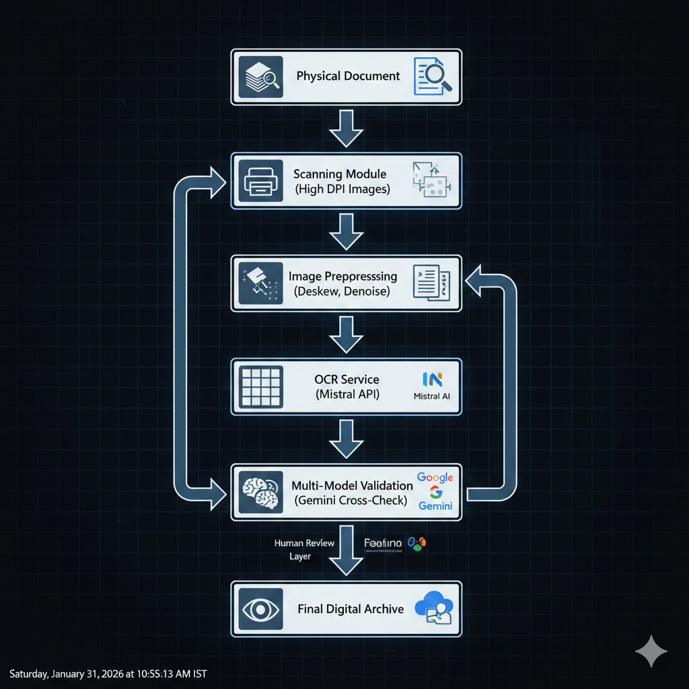

8. Extension: 500-Page Handwritten Book
The same pipeline was extended to digitize a handwritten 500-page manuscript intended for publication.
Additional challenges:
- Variability in handwriting
- Ink fading
- Non-uniform margins
- Stroke thickness inconsistencies
The same multi-model validation ensured higher reliability than single-model OCR systems.

9. Key Innovations
- Multi-model AI cross-validation
- Human-in-the-loop quality assurance
- Reusable digitization framework
- Scalable architecture
- Academic-grade accuracy preservation

10. Business & Enterprise Potential
This architecture can scale to:
- University thesis archives
- Legal document digitization
- Historical manuscript preservation
- Government record modernization
- Publishing house workflows
- Research archival systems
It is not just OCR — it is AI-driven digital preservation architecture.

